Hemlock Semiconductor Announces Major Investment in Thomas Township
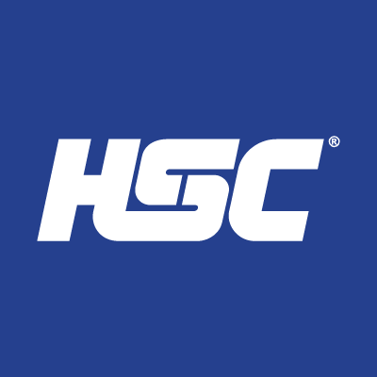
Hemlock Semiconductor (HSC), a Thomas Township business, and one of the global leaders in producing highly pure polysilicon, has announced a $375 million dollar capital investment which will create around 170 jobs.
To support these improvements, Thomas Township needs to make some wholesale infrastructure upgrades. Beginning at HSC’s plant, the Township will be building a new sewage pumping station, right sized for HSC’s needs not only today, but in the future as well. A new pipeline discharging from this station beginning at the corner of Gleaner and Geddes will be constructed carrying HSC’s sewer flows down Geddes to the east and beneath the Swan Creek. This new pipeline will terminate at the corner of Geddes and Kennely where the sewage will continue in a newly constructed gravity sewer. Our existing sewer system dead ends on Geddes near Glencairn, and will be extended to the west around 4,500 feet. With HSC’s flows now passing through the Township’s system, it will continue on to another pumping station located at the corner of Madeline and Sue. A new pipeline that discharges from this station will be constructed on Sue, Lydia, Rambling Dr., Sybil, and ultimately discharging into the existing gravity sewer pipeline located on McCliggott. The McCliggott sewer interior will then be lined and returned to service as “like new”.

“Hemlock Semiconductor’s investments in Michigan will create more good jobs in the Saginaw region and empower us to continue building and leading semiconductor production in our state,” said Governor Gretchen Whitmer. “Thanks to HSC’s continued investment in our state – which spans decades – Michigan will stay at the forefront of high-tech polysilicon production for the critical semiconductor and solar industries. The impact of this investment will be felt around the entire state for decades to come and build on our economic momentum as work to lead the future of this transformational industry right here in Michigan.”

https://www.michiganbusiness.org/press-releases/2022/09/infrastructure-investment-enables-hemlock-semiconductor-growth-michigan-semiconductor-supply-chain/

HSC Project Funding
The big question you are probably asking yourself is, “how are all of these improvements being paid for?” Thomas Township and Saginaw Charter Township (SCT), in partnership with HSC and with the help of Saginaw Future, as well as the Michigan Economic Development Corporation (MEDC) has secured a $37 million Strategic Outreach and Attraction Reserve (SOAR) grant from the State to support these critical infrastructure improvements.
Out of the $37 million granted, Thomas Township will receive $17 million to complete the improvements to the sewer transmission system, while Saginaw Charter Township will receive $20 million to increase sewer treatment capacity at the Wastewater Treatment Plant. An additional grant of $600,000 dollars was awarded by the Michigan Department of Transportation (MDOT) to help with the road re-construction costs of Geddes Rd.
Thomas Township will be the grant manager, and provide detailed oversight to the spending in order to keep the project on budget and schedule. This article will better outline the project specifics. Please direct any questions via email to either DPW Director, Rick Hopper at dpwdirector@thomastwp.org or to DPW Assistant Director, Trevor Schultz at dpwassist@thomastwp.org

Sewage Pumping Station #12
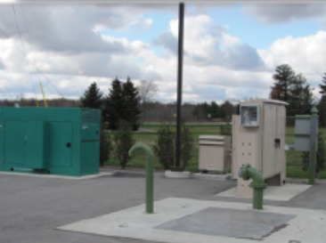
Located on the corner of North Gleaner and Geddes Roads, Pump Station #12 receives the sewage flows from the DuPont Health Materials Site and HSC. The current station pumps the sewage collected under pressure from the manufacturing sites down Gleaner Rd to the south, then east down M-46 to a discharge point near Van Wormer. From there, the sewage flows through large gravity sewers along the southern portion of Thomas Township, and ultimately to the treatment plant located in Saginaw Township on West Michigan Rd.
This new, larger capacity station will be constructed adjacent to the existing station. Capable of pumping up to 1,000,000 gallons per day, it will provide for additional service capability in this area. Consisting of a new block building, on-site natural gas generator, 2 submersible pumps, and a robust control system, this pump station will move the sewage effluent away from the site and into a new forcemain.
The project has been permitted by the State, and will be going out for bid in early December. This will allow for a construction timeframe of late Spring 2023 until the spring of 2024. The estimated cost to complete this improvement is $2,450,000 and will be 100% funded through the SOAR grant and the State of Michigan.
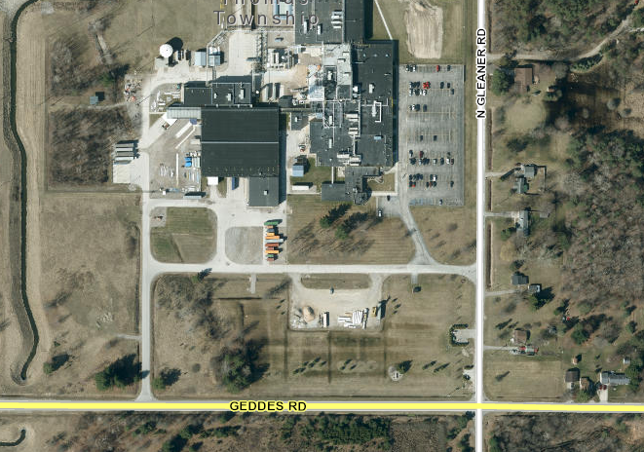

Geddes Road Forcemain Construction
The project will install a new pipeline needed for the new Pump Station #12 to move sewage from HSC to the Wastewater Treatment plant and is called a forcemain. Running east along Geddes Road from N Gleaner to Kennely, this new forcemain will be a continuous pipe, thermally welded together into a single pipeline. For the entire 2.8 miles of its length, 14-inch high density polyethylene pipe (HDPE) will be used.
Because this pipeline will be in service for decades to come, we have designed access points to it along its entire route. That will allow us to dewater, clean, and inspect the pipeline once it is in service. This foresight in the design will help us protect the pipeline in the future and allow preventive maintenance to be completed at regular intervals, prolonging the lifespan of the system.
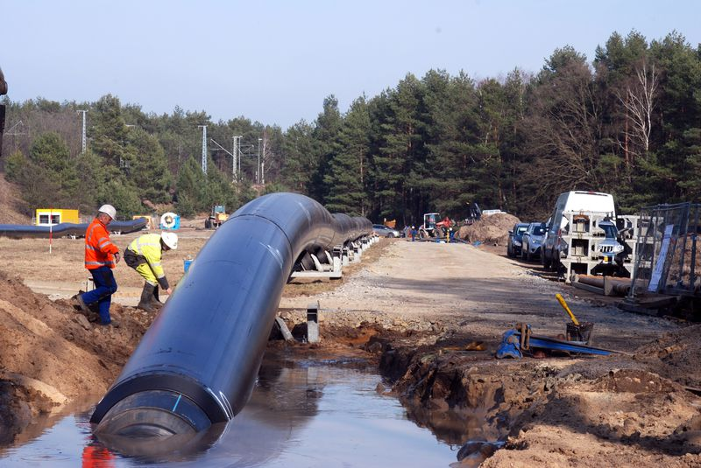
The new pipeline will be installed primarily within the road right-of-way along Geddes Rd and in easements beneath the Swan Creek. Because we will be impacting the shoulder of Geddes Road during construction, we will also be replacing the south lane of the road completely while milling down and adding a new wear course of asphalt on the north lane so the entire roadway will be restored and good as new.
This portion of the project has been permitted by the State, and will be going out for bid in early December. This will allow for a construction timeframe of late Spring 2023 until middle of 2024. The estimated cost to complete the pipeline and road restoration is around $6 million and will be 80% funded through the SOAR grant and 20% funded through MDOT.
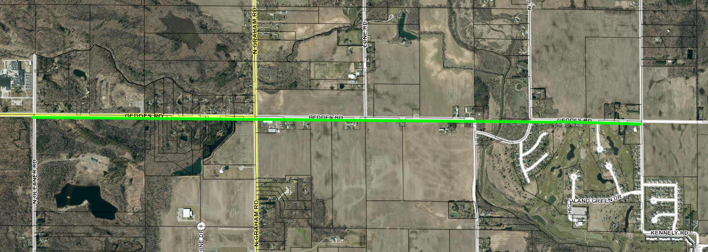

Geddes Road Gravity Sewer Project
Once the sewage is pumped from the HSC area and beneath the Swan Creek, it will empty into a new gravity sewer that will be constructed along Geddes Rd from Kennely to just west of Glencairn. This new pipeline will be an extension of the Township’s existing sewer pipe and is designed to handle the HSC flows while also opening-up the surrounding area to future sewer service.
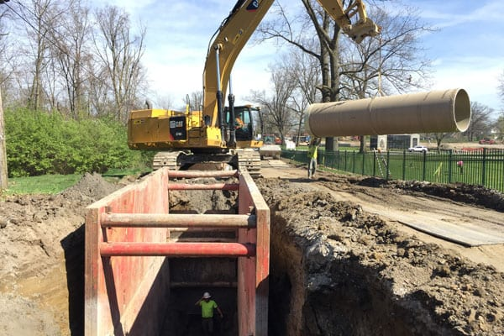
The new sewer will be built in easements that have already been attained along the south side of Geddes Road. A new sewer service pipe will be installed for each existing home and on the centerline of currently undeveloped parcels along this section. Current residents will not be required to abandon their existing septic tanks and reconnect to the Township’s new sewer; however, you will have the option to connect immediately after construction of the sewer main for a small cost. Whenever you wish to connect to the Township’s system, simply contact us (989-781-0150) at any time and we will assist you. As the septage rules are regulated by the Saginaw County Health Department, you may be directed by that office at some time in the future to connect to the new municipal system.
This portion of the project has been permitted by the State, and will be going out for bid in early December. This will allow for a construction timeframe of late Spring 2023 until late 2023. The estimated cost to complete this improvement is around $1,500,000 and will be 100% funded through the SOAR grant and the State of Michigan.
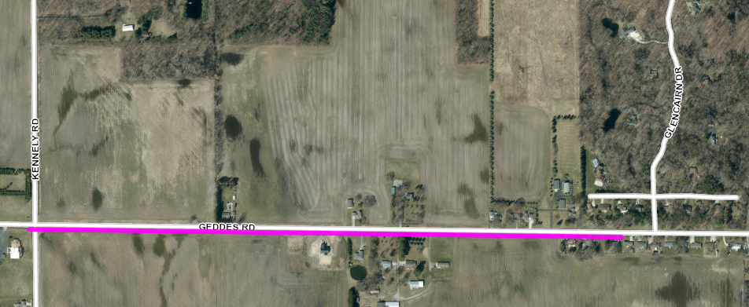

Madeline and Sue Pump Station Project (Pump Station #4)
The lynchpin to the entire HSC related sewer improvements is the re-construction of Pump Station #4 located on the corner of Madeline and Sue in Rambling Acres. The existing station is built partially on easement and in the road right-of-way and has been in continual service for over 50 years. Almost all of the current sanitary sewer flows that are generated in Thomas Township, between Gratiot (M-46) and Tittabawassee Roads, as well as between North River and North Thomas Roads currently flows through this station.
The original station was constructed in 1972 and has been in continual operation since. With modest updates made to the station during its lifespan, it is at a point where it needs to be totally re-constructed. Constructed mainly underground, it is subject to flooding and confine space issues, making it potentially unsafe to operate unless there are multiple staff members present when work needs to be completed.
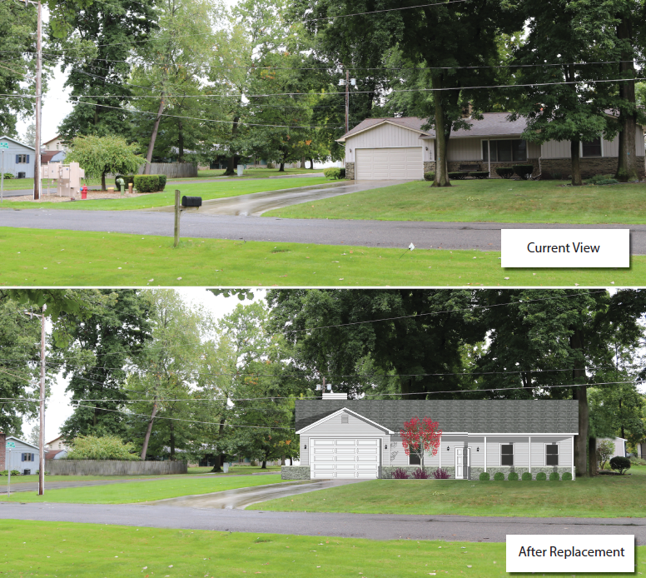
As this station is being re-constructed in a residential neighborhood, this poses some additional construction considerations. What should it look like? How do you keep it quiet? Will it smell? A lot of effort has gone into the new design and many innovative features will be incorporated in this project to answer all these types of questions.
Considering all of these factors, Thomas Township has been planning on updating this station for many years but has deferred these major improvements because of the large capital investment needed. Tie-barring this improvement to the HSC upgrades allowed us to secure outside funding to complete the project at a minimal cost to the Township. This saves our residents an enormous amount of money that they would otherwise have to fund within their sewer rates.
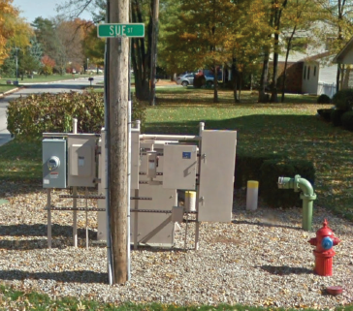
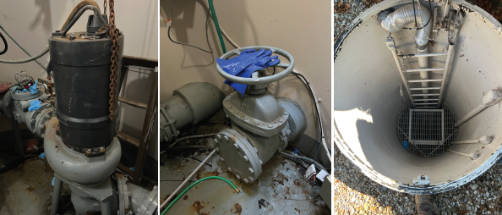

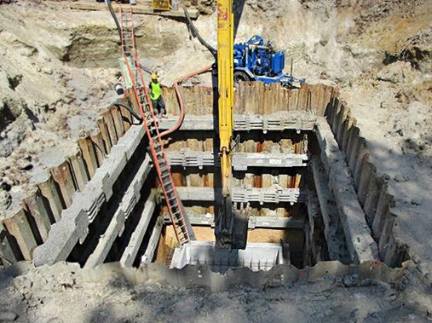
We have designed the new station to look just like a single-family residential home. The design uses state-of-the-art, energy efficient equipment that will lower the overall operation and maintenance costs over the 50-year lifespan of the equipment. Unique odor control systems and sound dampening measures will also be built into the new construction. Adding an onsite, natural gas generator will also protect the system, and your homes, from sewer backups due to power failures. Finally, this new project will not only replace the existing equipment with the new, it will also rebuild the existing house to host all the controls, piping, as well as the emergency generator. Once completed, it is our goal to have this pumping station blend in seamlessly with the surrounding neighborhood.
Additionally, because of the construction and truck traffic impact throughout the neighborhood, Madeline will be re-surfaced and residents of this neighborhood will be left with a road that is in better condition than before the project began.
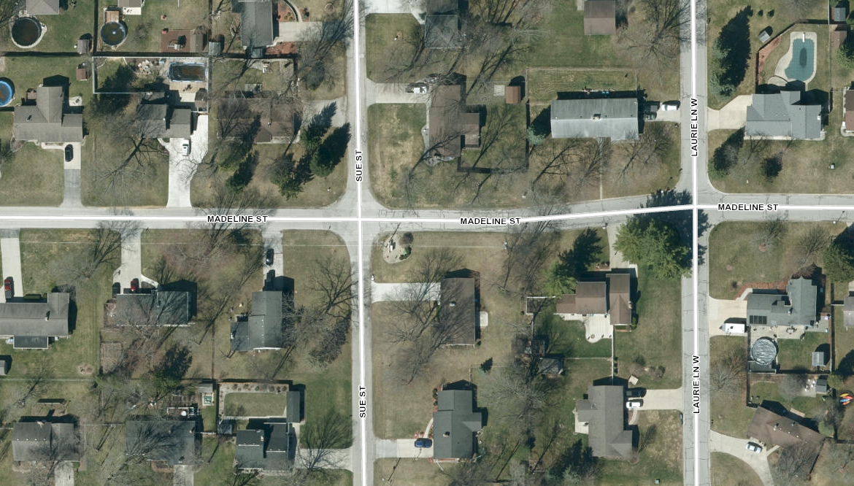
This portion of the project has not yet been permitted by the State, but will be going out for permit in mid-December. After permitting, we will advertise for construction in January which will allow for a construction timeframe of late spring 2023 until winter 2023. The estimated cost to complete this improvement is around $4,200,000, and will be 100% funded through the SOAR grant and the State of Michigan.

Rambling Acres Forcemain Project
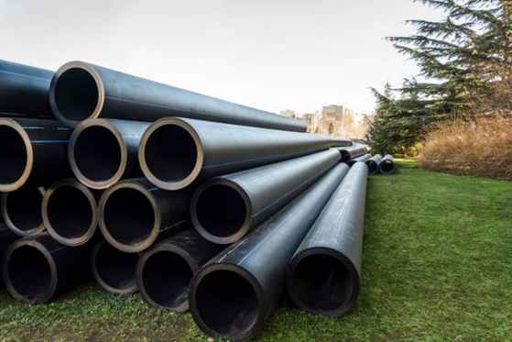
Because the existing 50 plus year old pipeline that currently exists has shown some signs of deterioration, it will be replaced with a new pipe. The Rambling Acres Forcemain project replaces the existing force main coming from the new Madeline and Sue pump station to its discharge point on McCliggott, just east of Briar Hill. The new force main pipe will be buried beneath the centerline of Sue, Cheryl, Rambling and a portion of Sybil streets. Once the pipeline is installed, those roadways will be rebuilt in the impacted areas.
The new pipe line will be 12-inch ductile iron pipe and installed much shallower than traditional gravity sewers. This means that construction should go much quicker and easier than conventional sewer projects saving both time and money. The existing force main that is currently in service will be abandoned in place, so it can be rehabilitated and placed into service with minimal cost, effort, and disruptions should the township-wide sewer system ever need to be expanded upon sometime in the future.
This portion of the project has not yet been permitted by the State, but will be going out for permit in mid-December. After permitting, we will advertise for construction in January which will allow for a construction timeframe of late Spring 2023 until late 2023. The costs associated with this portion of the project are included in the Madeline and Sue pump station costs.
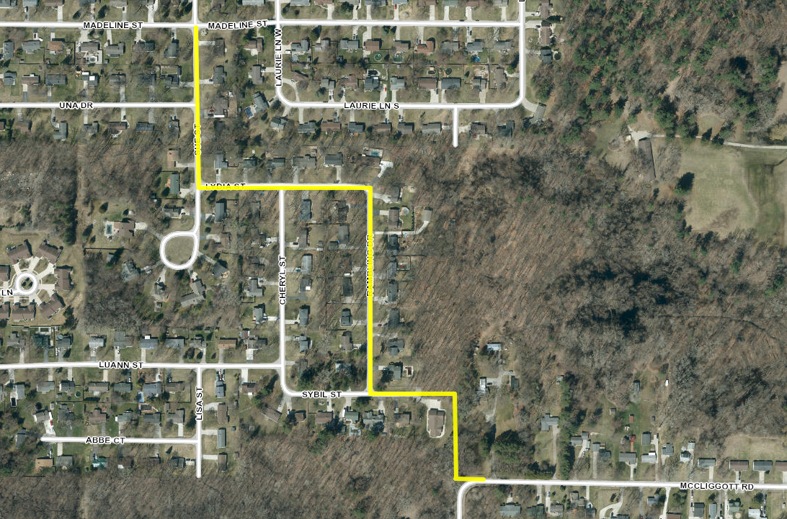

McCliggott Road Gravity Sewer CIPP Lining Project
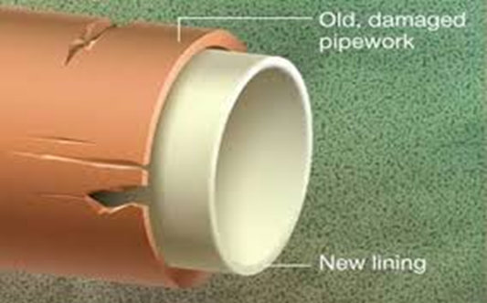
Thomas Township is always looking at ways to maximize the useful life of its infrastructure and to make sure that the investments being made are smart and efficient. This means melding our new infrastructure improvements into our existing system where it makes financial sense and does not compromise the overall integrity of the system. The McCliggott gravity sewer relining project is a good example.
The current 27-inch gravity sewer on McCliggott accepts the sewage flows from the Madeline and Sue pump station and carries that flow to the east, dumping into a large sewer on North River Road. Early in this project, extensive studies were completed to see if the sewers along North River to Stroebel Road could be reused in this project, paying particular attention to McCliggott. Even though these sewer pipes are a half-century old, they are in good structural shape to remain in service for another 50-100 years with a just a little bit of rehabilitation.
This project will install a liner into the existing sewer in a process called “cured-in-place pipe” lining or CIPP lining for short. During this project, the existing sewer will be relined from Briar Hill to Gillette Street. Completed without having to excavate down to the actual sewer, the process will install this lining from one manhole to another. After the lining cures (which is usually just a couple of hours) the interior of the pipe is strengthened significantly with a liner that is corrosion and erosion resistant.
This portion of the project has not yet been permitted by the State, but will be going out for permit in mid-December. After permitting, we will advertise for construction in January which will allow for a construction timeframe of late spring 2023 until winter 2023. The estimated cost to complete this improvement is around $625,000 and will be 100% funded through the SOAR grant and the State of Michigan.
